Access to Expense Tool
To access the tool, you would go to my.rutgers.edu and click on Log In (right corner). Once in, go to the Finance section (you may need to click on the More box in the center bottom to see more options). Click on Expense Management.

No Access to Expense Tool?
Go to https://finance.rutgers.edu/resource-library/forms-and-templates . Under Financial Management System Access Forms, choose Expense Management document. Complete the form, obtain necessary approvals and scan/email the form to cloudaccess@finance.rutgers.edu.

Finance Approver Change?
If employees require a change to the Finance Approver, the Finance Approver Form is found under https://finance.rutgers.edu/resource-library/forms-and-templates. Under Financial Management System Access Forms, choose Finance Change Approver Forms. Open the document. Complete the form, obtain necessary approvals and scan/email the form to cloudaccess@finance.rutgers.edu.

Project Approver Change?
For non-sponsored projects, go to the Project Request Form found under http://uco.rutgers.edu/forms-repository. Under Available Forms, choose Project Request Form and choose New Project Request Form. Open the document and go to the Change Existing Project tab. Complete the form, obtain necessary approvals and scan/email the form to coa@finance.rutgers.edu .

Training for Expense (Employee)
Web-based training is located at
• Go into https://onlinelearning.rutgers.edu/canvas .
• From there, click on Canvas Login
• Sign in with your NetID and password
• Go into Dashboard on the left
• Click on Expense Management Course Pathway
• Click on Modules
- Expense Management Instructor Led Training Classes

Requires Action or Manager Requests More Information
If an employee receives notification that their report Requires Action, they should
- Click on the Notification Bell 
- Open the notification
- Make the necessary corrections or to upload required receipts, click on the +
- Click Ok
- Go up to Actions in the top right corner and from the drop down, choose Submit

Reports Returned with Error Messages
Click on the Notification Bell, not the report number. Correct the errors or add the necessary information. Click ok then go to Actions in the top right corner and from the drop down, choose Submit

Withdraw and Resubmit
To withdraw a report, go to the home page, and click on the three dots next to Approval Requested in the Expense Report box. Choose Withdraw. Click on Yes in the Warning pop up. You can then go back in, make any changes and hit Submit.

Delegate
To assign a delegate, the employee will have to choose . Choose Manage Delegates.
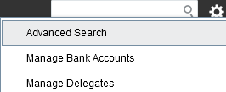

Once in Delegates and Permissions, click on the +. 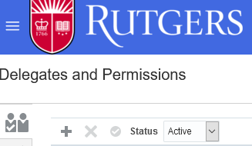

Click on the magnifying glass next to Person. Search and Select: Person will come up.
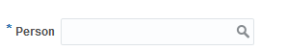
Click on Advanced button.

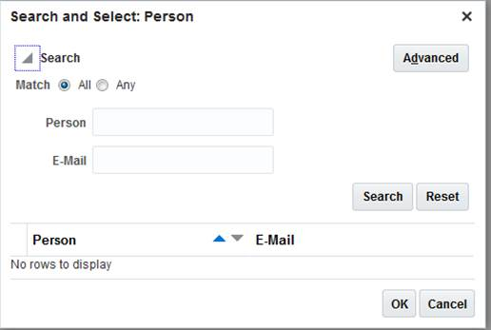

Under email, type the beginning of the delegate’s email address and click Search. The person’s name should come up below. Highlight the line with the email address by clicking on it and click OK.
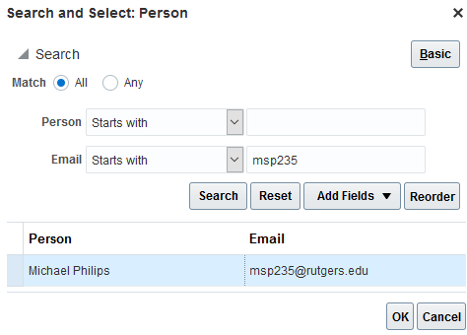

How do I change the account string?
Within the actual expense, the account string is changed by clicking on 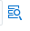 next to the account number. Once clicked on, it will drop down to show the individual string segments. The one segment you do not change is Account since that indicates the type of expense you selected. If charging a project, do not change the Account string. Project information is charged automatically, once the report is fully approved.

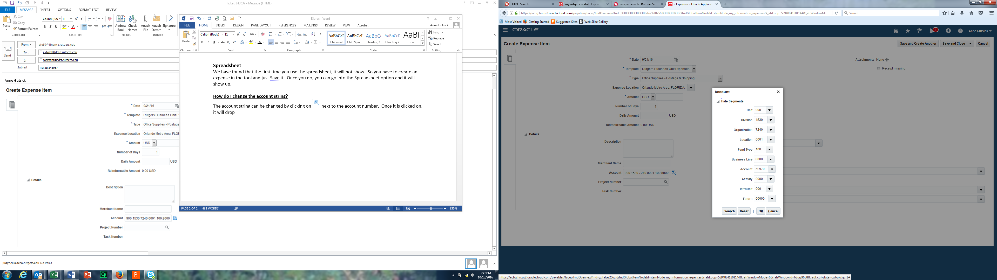

Cash Advances
Delegates do not have the ability to submit cash advances on behalf of an employee.

Creating a Cash Advance
Go into Expense Management, to the Home page and go the Cash Advance icon on the left. Choose Request Cash Advance.
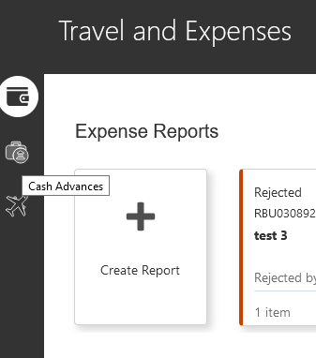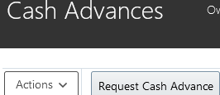

Populate the information required, attach necessary back up and hit Submit. Cash Advance requests will go to the employee’s Finance Approver for approval and, once approved, are paid out two weeks prior to the Trip Start Date.

Check Banking Info

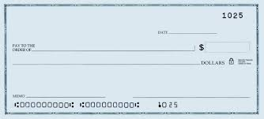

Routing # Account #
Adding Banking Information

To enter banking information in Oracle Expenses, go to the Task Icon on the right side of the page. The employee will have to first go to and then choose Manage Bank Accounts from the drop down list.

The first step is to click on the + to add your banking info.
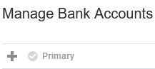

Complete all of the info with an * and add your Bank and Branch. Do not enter any spaces or dashes.
For Account Type, do not choose Money Market. Only Checking and Savings. (Routing number needs to come from a check and not a deposit slip).

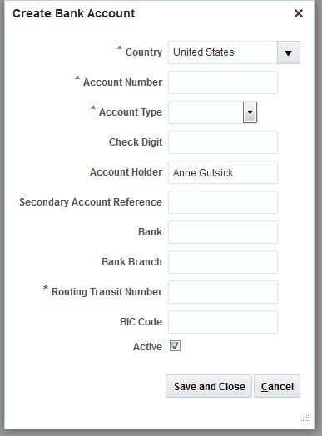

Once the info is entered, click on Save and Close. The final step is to make your bank the Primary so you would click next to Valid to highlight the row. Then click on Primary. A check box should show up to the left of your bank name.

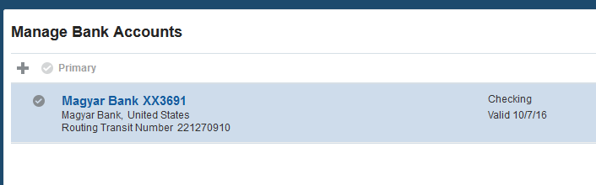

Payment Method Types
- ACH-BOA-PPD = direct deposit to employee bank account from Rutgers Bank of America account
- Check BOA = check payment from Rutgers Bank of America account
- Wire = wire payment (DO NOT USE)

Setting Up Vacation Rules (Approvers)
Vacation rules must be set from the approver’s login. While setting up vacation rules the user has an option to either Re-Assign the expense report or Delegate it. There are two different Re-Assign roles:
- Re-Assign removes the expense report from the default approver’s queue and sends it to the person whom it has been re-assigned to.
- Delegate Workflow appears simultaneously in both logins, in essence, the default approver’s and the person whom it has been delegated to.

Illustrated steps to set up vacation rules:

- Login and choose the Notification bell

- Choose More Details
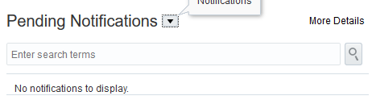

- From the new pop up window, click on the drop down arrow to the right of your name
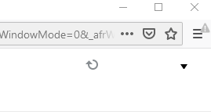

- Select Preferences
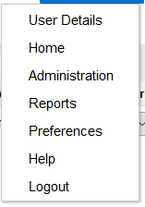

- Once the vacation rule page appears, the following fields need to be entered:
  - Enable vacation period – Tick the box
  - Start and End date – range of the vacation period
  - Tick the radial button for Reassign to then enter to whom OR
  - Tick the radial button for Reassign or Delegate. Enter the Net ID of the person who the reports will be reassigned to. (Both re-assign and delegate options cannot be used simultaneously)
  - Choose Save when done. Rule should revert based on End Date but can be manually reverted.
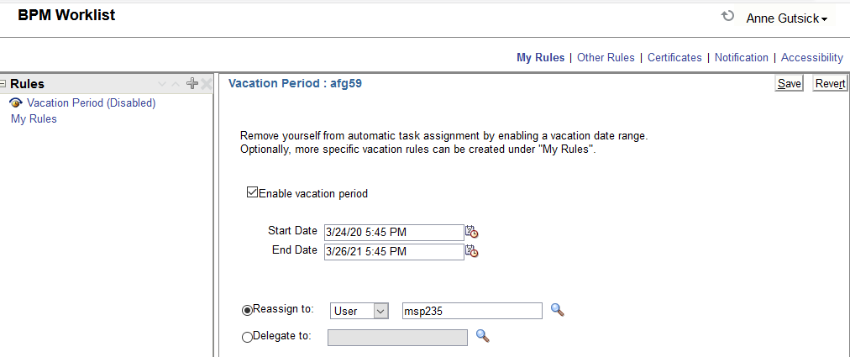

Finance Approver Report
- Go into Oracle and click on the Navigator button in the upper left corner 
- Click on Reports and Analytics
- A new window will open, click
- Click on Browse Catalog in the upper right part of the page
- Click on the arrow to the left of Shared Folders
- Click on the arrow to the left of Custom
- Click on the arrow to the left of RU Custom
- Click on the arrow to the left of Reports
- Click on the arrow to the left of ATC Reports
- Choose RU GL 002 Finance Approver Lookup Report and click Open
- A new window will pop open
- Under Employee Name, unclick All and click on Search
- In the box to the right of Starts with, enter the employee’s last name, then Search
- Highlight by clicking on employee’s name and then click on >Move, then OK
- Click on Apply to the far right and your report will run in Excel.
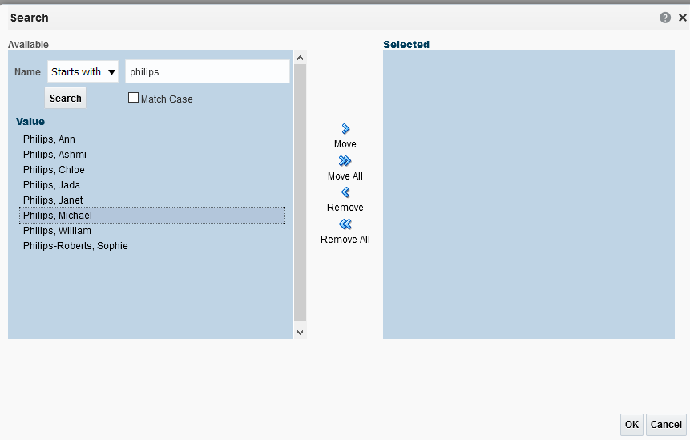

View reports for those you are a delegate for or yourself:
- Choose name from drop down list of those you are the delegate for or your own name
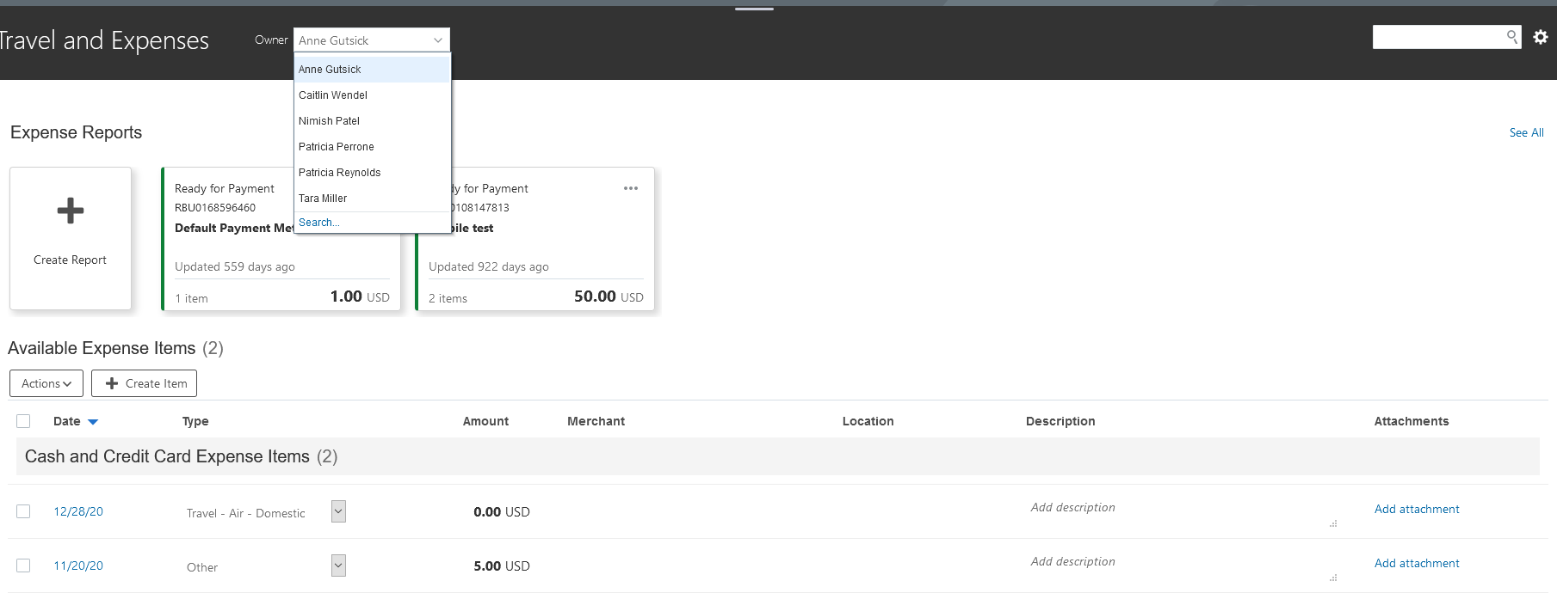
- Note: System advises who you are managing expenses for

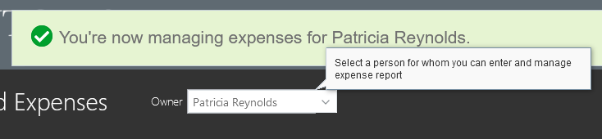
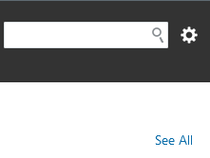
- Choose See All

4. All Expense reports for the employee chosen will show. Click on RBU number to go into the report. Note if paid, the Payment Date is in the far right column.

To view reports a full year of reports:

- Follow the directions in the section above.
- Click on the arrow to the left of Search and the window expands 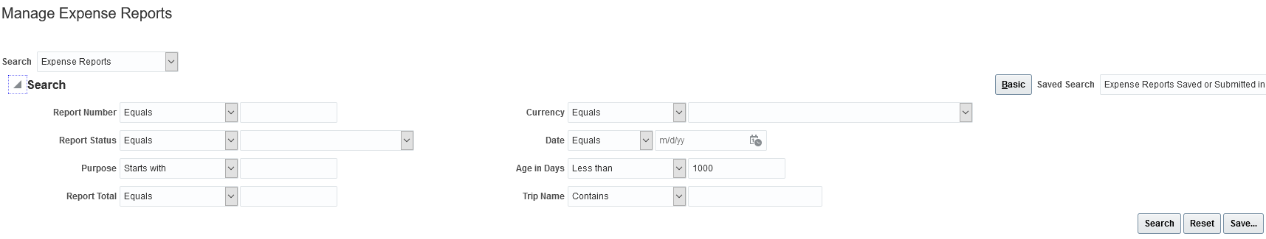
- System automatically shows 180 days. In “Age in Days : Less Than” change the 180 to 365 for a full year or whatever number you need then hit Save. Next, choose Search and reports for that time period will show.

Finance Approvers – How to view reports you have approved

- Click on the Notification Bell
- Click on More Details
- Click on Administrative Tasks
- Enter name of employee 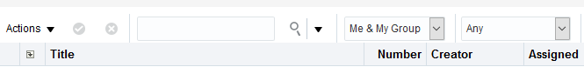
- Change Assigned to Any 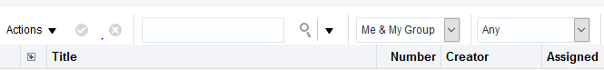
- Click on the magnifying glass to Search

Project Approver Report

- Go into Oracle and click on the Navigator button (to the left of Rutgers logo). Based on the access you have, your screen may appear slightly different
- From there go to Projects – Project Financial Management

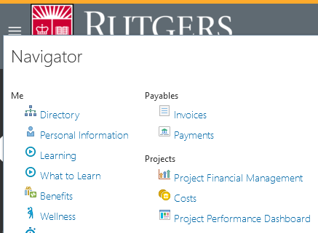

- Click on the arrow to the left of Search to expand the window.

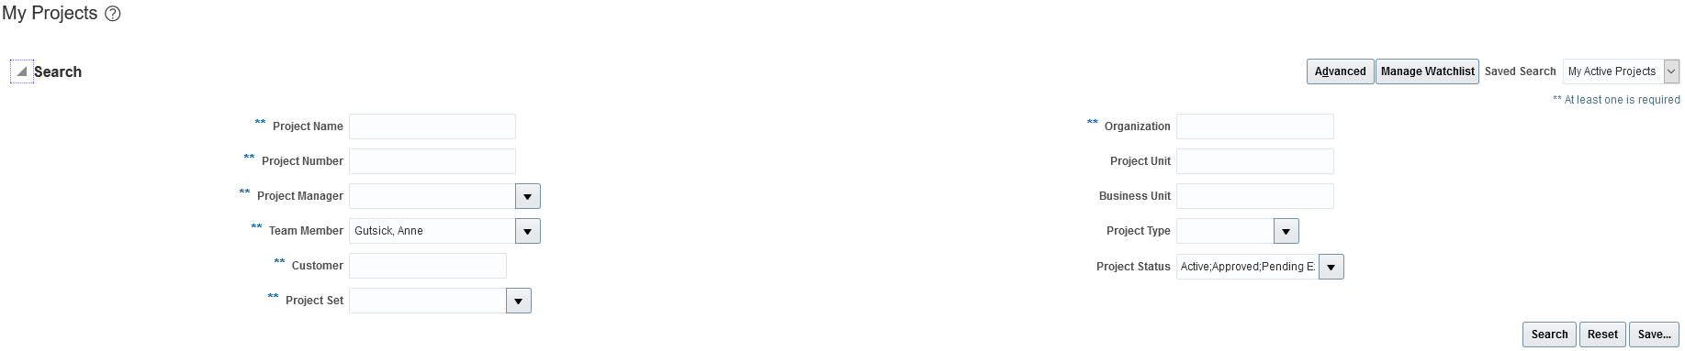

- Remove your name as the Team Member, add a Project Number or Project Manager and then click Search.

- You can then export the file to Excel for slicing and dicing.

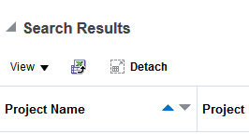

Print Expense Report After Submitting

- Go into Oracle Expense and choose See All on the far right side of the home screen. 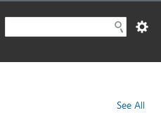
- Click on the dollar amount of the report that needs printing to change the line blue. 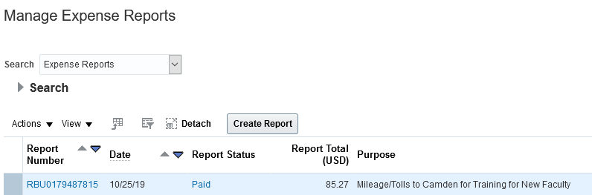

- From Actions, choose Print Preview
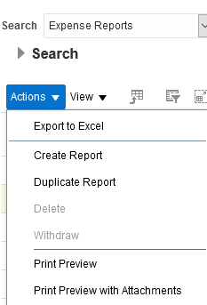

Access to Enterprise Car Rental
Go to the Procurement website at https://procurementservices.rutgers.edu/purchasing/travel-and-expenses/car-rental-and-ground-transportation or go into my.rutgers.edu (Rutgers Portal) and log in. Under the Finance and Purchasing section, choose Accounts Payable and Travel Forms.
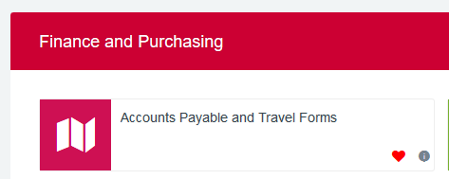

If you do not have visibility to this, on the My Apps tab in the upper right, you will see View with a drop down arrow. Choose All and then Save. The tile should now show. Click on it.
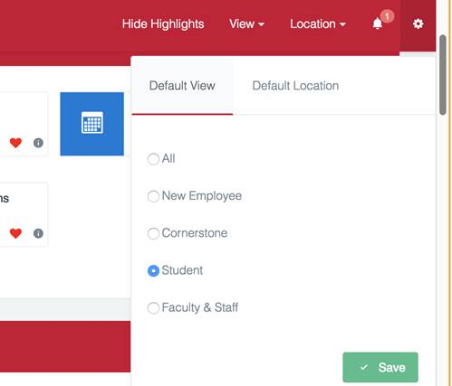

The Accounts Payable and Travel Forms tile will show as below. The directions on using are included. If the rental is for Personal use, then the user should use XZ24RPU under Optional.

